Geneious plugins for the access of PlasmoDB and PiroplasmaDB databases
Screenshots
After installation of the plugin the database icon “PlasmoDB” appears on the Source Panel (Fig 1 Arrow A).
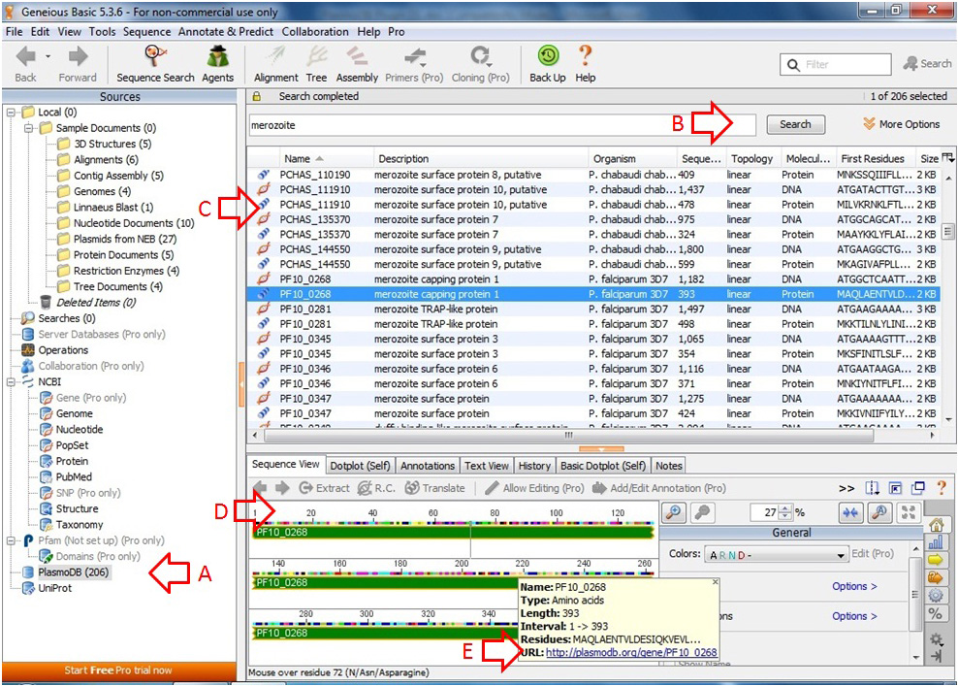
Fig 1: The appearance of the main window when the plugin for accessing PlasmoDB is in use. Arrow A: Icon of PlasmoDB in the Sources Panel; Arrow B: Search Box in Fewer Options mode; Arrow C: Retrieved DNA and protein sequences in the Document Table; Arrow D: Document View of selected sequence; Arrow E: Tip Window of the selected sequence. The URL link in the Tip Window allows immediate access of detailed information from PlasmoDB.

When the icon is selected, the Search Tab appears in the Document Table and users can search PlasmoDB via Genious (Fig 1 Arrow B). In the default search setting data of all the species in the databases will be retrieved. If “More Options” is selected specific species can be selected (Fig 2) and data of only the selected species will be retrieved. Fig 1 Arrow C points to an example of the Document Table after a search showing DNA and protein sequences displayed separately. When a specific sequence is selected it will become visible in the Document View panel (Fig 1 Arrow D). Moving the cursor over the annotated region (continuous bar) of the sequence in the Document View panel, a Tip Window will appear (Fig 1 Arrow E). The URL link in this window will open up the selected gene/protein on the webpage of PlasmoDB with the default web browser so that users can refer to other information available.
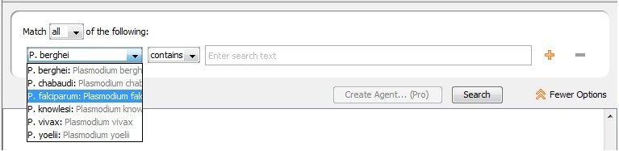
Fig 2: Search Box in More Options mode.

The scope of the text search function mentioned above covers the product name, notes, Gene Ontology (GO) terms, Enzyme Commission (EC) descriptions, protein domain descriptions, National Resource Database (NRDB) protein names and metabolic pathways descriptions kept in PlasmoDB (http://plasmodb.org/plasmo/showQuestion.do?questionFullName=GeneQuestions.GenesByTextSearch). When multiple words are entered in the search text panel, all data that matches one of these words will be retrieved. If only data that matches all of the words is required, the search text should be quoted, e.g. “Hsp70 ATPase”. Apart from providing text for the search, users can also enter the gene ID to obtain information of a specific gene, e.g. PF11_0344.

